**Cartoon On AI**

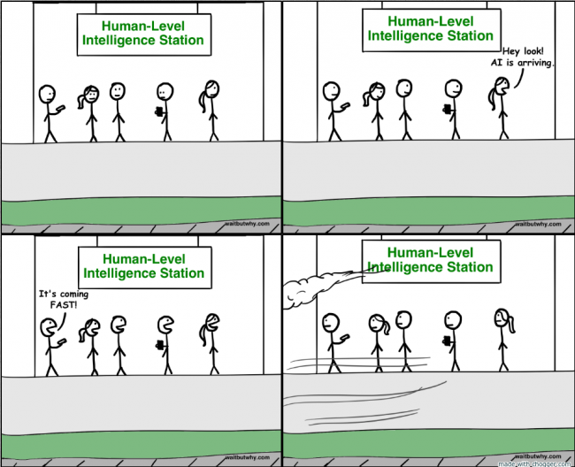

**Reference Link:** [**https://www.ilicomm.com/how-artificial-intelligence-will-change-our-lives-for-better-or-worse/**](https://www.ilicomm.com/how-artificial-intelligence-will-change-our-lives-for-better-or-worse/)